AI-Assisted Root Cause Analysis
Engineer Needs & Computational Requirements
Context: Nuclear Power Plant Operations
Version 1.0 | Project Inception Document

1. Purpose & Scope
This document establishes a comprehensive, integrated foundation of engineer needs and computational capability considerations for the development of AI-, ML-, and statistically-enabled tools to support Root Cause Analysis (RCA) and troubleshooting in nuclear power plants.
It integrates:
- Fundamental systemic considerations for nuclear RCA (data, causality, uncertainty, interdependencies, human factors, safety context)
- Practical engineer-driven needs (data silos, regulatory defensibility, CAP integration, knowledge retrieval, structured methodology compliance)
This document is intended to serve as the conceptual starting point for formal requirements drafting and software architecture design.
The tool suite is explicitly decision support, not decision automation. Final technical and regulatory conclusions remain the responsibility of licensed engineers.
All development must remain consistent with industry guidance from the Electric Power Research Institute (EPRI), the Nuclear Energy Institute (NEI), and regulatory expectations of the U.S. Nuclear Regulatory Commission (NRC)

2. Operating Context: Why Nuclear RCA Is Uniquely Challenging
Root cause analysis in nuclear power plants differs fundamentally from generic industrial troubleshooting due to:
- Defense-in-depth safety philosophy
- Highly coupled, redundant system architectures
- Low failure frequency / high reliability regime
- Strict regulatory documentation and auditability requirements
- Multi-disciplinary engineering integration
- Long asset lifetimes and aging degradation modes
- Cultural emphasis on conservative decision-making
The computational system must therefore support:
- Technical rigor
- Traceability
- Uncertainty transparency
- Human primacy
- Conservative inference bias
- Long-term knowledge preservation

2.1 Engineer Needs Overview
The diagram below maps the six identified engineer need areas to the computational RCA tool and its derived capability requirements. Colored nodes represent engineer needs; gray nodes represent specific analytical capabilities derived from those needs.

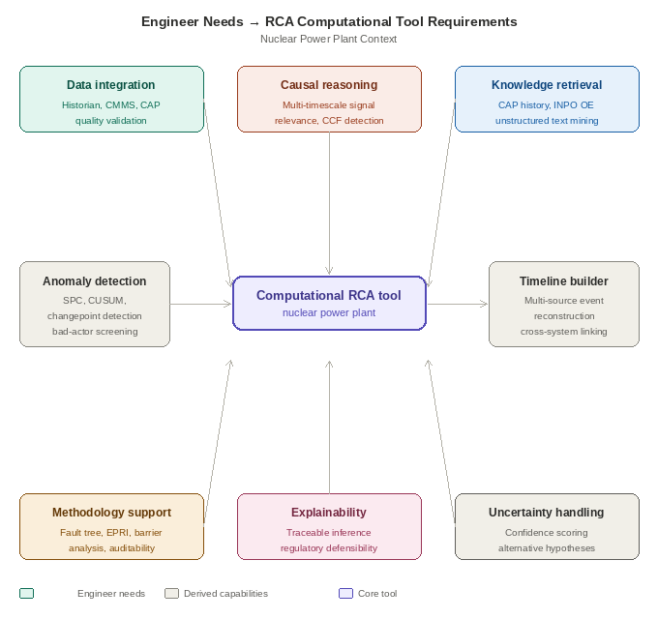
Figure 1. Engineer needs (colored) mapped to core RCA tool capabilities. Arrows indicate the need drives the capability requirement.

3. Critical Engineer Need Areas
The following sections describe each need area in detail, including the specific pain points that engineers encounter and the computational capabilities required to address them.

3.1 Data Access, Quality, and Integration
Problem Landscape
Plant-relevant information resides across fragmented systems:
- Process historians (high-frequency time series)
- Maintenance management systems
- Surveillance and testing databases
- Corrective Action Program (CAP) databases
- Operating experience (OE) repositories
- Protection system event logs
- Operator narrative logs
- Paper and legacy records
Engineers spend disproportionate time assembling and cleaning data rather than performing causal reasoning.
Key challenges:
- Timestamp misalignment
- Heterogeneous sampling rates
- Sensor drift, frozen values, rail conditions
- Outage gaps
- Cross-system entity disconnection
- No unified ontology linking equipment, work orders, and CAP records
Required Foundational Capabilities
- Multi-source ingestion framework with provenance tracking
- Unified timebase alignment across heterogeneous systems
- Automated data quality scoring and bad-actor detection
- Signal health monitoring and sensor reliability indicators
- Cross-system entity resolution (tag → equipment → work order → CAP record)
- Version-controlled data snapshots for RCA defensibility
This is the non-negotiable Phase 1 foundation. No analytical reliability exists without it.

3.2 System Topology, Functional Modeling & Defense-in-Depth Mapping
Problem Landscape
Nuclear plants are:
- Redundant (A/B trains)
- Cross-tied
- Interlocked through permissives and trips
- Supported by shared auxiliary systems
- Structured around safety functions
Symptoms frequently appear far from initiating causes.
Engineers must reason across:
- Physical configuration
- Functional relationships
- Protection logic
- Safety barriers
Required Capabilities
- Graph-based system topology model (equipment, systems, safety functions)
- Representation of redundancy and independence assumptions
- Protection logic modeling (permissives, trips, interlocks)
- Automatic mapping of affected safety functions
- Defense-in-depth barrier identification (which barriers failed, which succeeded)
- Visualization of degraded defense layers
This enables movement from correlation analysis to causal modeling grounded in plant architecture.

3.3 Signal-to-Noise & Event Identification
Problem Landscape
A single unit may contain 20,000–40,000 instrument channels.
Challenges include:
- Alarm flooding
- First-out signal identification
- Consequential alarm cascades
- Distinguishing symptoms from causes
- Rare-event detection
- Multi-timescale causality (milliseconds to months)
Engineers face:
- Proximate cause trap
- Confirmation bias
- Blindness to common-cause failures (CCF)
Required Capabilities
- Alarm clustering and cascade suppression
- First-out event detection logic
- Statistical Process Control (SPC)
- CUSUM for slow drift detection
- Changepoint detection
- Cross-channel correlation analysis
- Granger causality exploration (with caution)
- CCF screening against independence assumptions
- Multi-timescale pattern detection
The system must reduce cognitive overload without hiding critical signals.

3.4 Temporal Reconstruction & Timeline Intelligence
Problem Landscape
Causality is temporal.
Engineers often manually reconstruct:
- Event chronology
- Protection actuations
- Operator actions
- Maintenance overlaps
- Repeated intermittent failures
This is time-intensive and error-prone.
Required Capabilities
- Automated multi-source event timeline construction
- Millisecond-resolution sequence reconstruction (where data allows)
- Slow degradation visualization across weeks/months
- Comparative timeline matching with historical events
- Highlighting of precursor signatures
Timeline reconstruction is one of the highest near-term ROI capabilities.

3.5 Rare Events & Low-Frequency Failure Environment
Problem Landscape
Nuclear plants operate in high reliability regimes.
Traditional ML struggles because:
- Labeled failure data is sparse
- Many failure modes are rare or novel
Required Capabilities
- Hybrid physics-informed + statistical modeling
- Bayesian inference frameworks
- Anomaly detection over classification reliance
- Transfer learning across fleet data
- Explicit uncertainty quantification
- Conservative bias in sparse-data contexts
Black-box inferences shall not be used for safety-significant conclusions without traceable evidence pathways.

3.6 Latent Degradation & Aging Detection
Problem Landscape
Gradual degradation precedes many failures:
- Fouling
- Calibration drift
- Valve stiction
- Aging cable insulation
- Procedural erosion
These signals are often weak and long-term.
Required Capabilities
- Long-horizon trend analysis
- Cross-cycle comparison
- Fleet-wide pattern mining
- Change detection under noisy conditions
- Early weak-signal amplification
This supports preventive correction rather than post-failure RCA only.

3.7 Institutional Knowledge Preservation & Retrieval
Problem Landscape
Critical knowledge exists in:
- CAP narratives
- Industry OE reports
- Historical RCAs
- Informal expert experience
Much of this is unstructured text and difficult to retrieve.
Required Capabilities
- NLP-based semantic search across CAP and OE records
- Similarity matching between current symptoms and historical cases
- Structured encoding of prior RCA findings
- Knowledge graph linking failure modes, contributors, corrective actions
- Retirement-resilient knowledge capture
The system becomes a long-term institutional memory.

3.8 Structured Methodology Compliance & Analytical Flexibility
Methodology frameworks shall be dynamically linked to the underlying system topology and safety function model.
Problem Landscape
RCA must follow structured methods:
- Fault trees
- Barrier analysis
- Change analysis
- Event and causal factor charting
However:
- Over-rigidity may obscure novel failure modes
- Regulatory defensibility is mandatory
Required Capabilities
- Computer-aided fault tree construction
- Barrier analysis templates integrated with system topology
- Change analysis workflow support
- Audit trail from raw data to final conclusion
- CAP-ready documentation export
- Evidence traceability for every inference
The tool must enhance rigor without constraining exploration.

3.9 Uncertainty Quantification & Hypothesis Management
Problem Landscape
Evidence is often incomplete or degraded.
Current RCA practice frequently forces binary conclusions.
Risks:
- Overstated certainty → under-scoped corrective actions
- Over-broad actions → wasted resources
Required Capabilities
- Probabilistic confidence scoring
- Explicit evidence-gap representation
- Alternative hypothesis ranking
- Divergence explanation between hypotheses
- Sensitivity analysis under data-quality assumptions
- Distinction between “evidence against” and “insufficient data”
Uncertainty must be visible, not hidden.

3.10 Cognitive Bias Mitigation
Problem Landscape
Engineers are subject to:
- Anchoring
- Confirmation bias
- Availability bias
- Authority bias
These can truncate causal exploration prematurely.
Required Capabilities
- Automatic generation of alternative hypotheses
- Structured “disconfirming evidence” surfacing
- Hypothesis comparison dashboards
- Blind analysis modes where appropriate
The system should act as a cognitive challenger.

3.11 Multi-Disciplinary Collaboration & Workflow Integration
Problem Landscape
RCA spans:
- Mechanical
- Electrical
- I&C
- Operations
- Human performance
- Chemistry
Current collaboration is fragmented.
Required Capabilities
- Shared hypothesis workspace
- Hypothesis ownership tracking
- Version control of causal branches
- Structured dissent/comment capability
- Engineer override logging with rationale capture
Collaboration strengthens institutional learning.

3.12 Risk Significance & PRA Integration (Strategic)
Problem Landscape
Beyond cause identification, plants must evaluate:
- Safety function impact
- Barrier effectiveness
- Risk significance
Corrective actions are often risk-informed.
Required Capabilities (Long-Term)
- Mapping of event impacts to safety functions
- Interface capability with PRA models
- Qualitative risk significance scoring
- Identification of barrier weaknesses
- Risk-informed corrective action prioritization
This is likely Phase 3+ but should inform architecture from the beginning.

4. Human–Machine Collaboration & Trust Calibration
Transversal requirement across all domains.
Design Principles
- Human primacy: engineer directs analysis
- Interrogability: “Why are you suggesting this?”
- Transparent uncertainty
- Clear boundaries of competence
- Conservative inference bias
- Graceful degradation under missing data
Required Interface Capabilities
- Drill-down evidence chains
- Plain-language explanation summaries
- Hypothesis workspace manipulation
- Explicit confidence labeling
- Override logging for continuous model improvement
Trust must be earned through transparency.

5. Analytical Operating Modes
The system must support distinct modes:
Rapid Triage Mode
- Immediate troubleshooting
- Alarm prioritization
- First-out identification
- Preliminary hypothesis surfacing
Deep Forensic RCA Mode
- Structured methodology integration
- Full uncertainty representation
- Documentation support
- Regulatory defensibility outputs
Architecture should allow progressive analytical refinement.

6. Model Governance & Lifecycle Management
Because this is nuclear: Baseline configuration management of plant model snapshots (design changes, ECNs, setpoint revisions).
Because this is nuclear:
- Algorithm version control required
- Configuration management
- Model validation & periodic re-validation
- Performance monitoring for drift
- Controlled update mechanisms
- Full audit logging of model changes
ML governance must be embedded from inception.

7. Cross-Cutting Non-Negotiables
Interpretability shall take precedence over marginal predictive performance gains from opaque models.
- Regulatory defensibility
- Explainability over black-box optimization
- Cybersecurity and on-prem/private deployment capability
- Auditability of all system actions
- Conservative bias in sparse-data contexts
- Graceful failure modes
- No automated closure of RCA without human authorization

8. Foundational Capability Pillars (Architecture Guidance)
From these needs, six architectural pillars emerge:
- Data Fusion & Quality Layer
- Plant Topology & Functional Knowledge Graph
- Temporal & Statistical Analytics Engine
- Causal Reasoning & Hypothesis Management Layer
- Institutional Knowledge & NLP Retrieval Engine
- Explainable Interface & Collaboration Layer
All future requirements and code architecture decisions should map to one or more of these pillars.

This document is a living requirements input. It should be reviewed and updated at each major project milestone.

